PIZZA SALES SQL QUARIES
A:- KPI’S
- Total Revenue:
Select Sum(total_price) As Total_Revenue From pizza_sales;
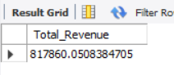
- Average Order Value :
Select Sum(total_price ) / Count(Distinct order_id) As Avg_Order_Value From pizza_sales;
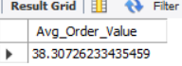
- Total Pizza Sold:
Select Sum(quantity) As Total_Pizza_Sold from pizza_sales;
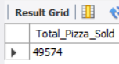
- Total Orders:
Select Count(Distinct order_id) As Total_Orders from pizza_sales;
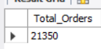
- Average Pizza per Order:
Select Sum(quantity)/ Count(Distinct order_id) As Avg_Pizza_Per_Order From pizza_sales;
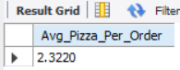
B. Daily Trend for Total Orders
Select Dayname(order_date) As order_day, Count(Distinct order_id) As Total_Orders From pizza_sales
Group By Dayname( order_date);
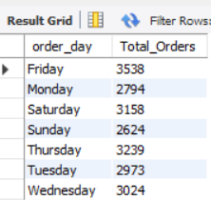
C. Monthly Trend for Orders
Select Monthname(order_date) As Month_name, Count(Distinct order_id) As Total_Orders From Pizza_sales
Group By Monthname(Order_date);
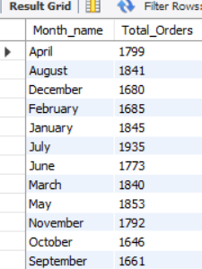
D. % of Sales by Pizza Category
Select pizza_category ,Cast(Sum(total_price) As decimal(10,2)) As total_revenue,
Cast(Sum(total_price)*100/(Select Sum(total_price) from pizza_sales)As decimal(10,2)) As PCT_of_total_Sales
from pizza_sales
group by pizza_category;
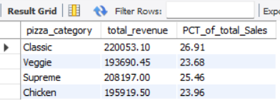
E. % of Sales by Pizza Size
select pizza_size , Cast(sum(total_price)AS DECIMAL(10,2))As total_sales,
Cast(Sum(total_price)*100/(Select Sum(total_price) from pizza_sales )As decimal(10,2)) As PCT_of_pizza_size
from pizza_sales
group by pizza_size
Order by pizza_size;
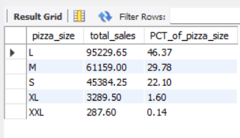
F. Total Pizzas Sold by Pizza Category
Select pizza_category , Sum(quantity)As Total_Quantity_Sold
From pizza_sales
Group by pizza_category
Order by Total_Quantity_Sold Desc;
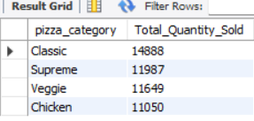
G. Top 5 Pizzas by Revenue
Select pizza_name,Sum(total_price) As Total_Revenue
from pizza_sales
Group by pizza_name
Order by Total_Revenue Desc
Limit 5;
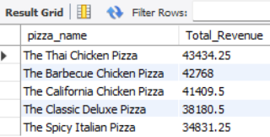
H. Bottom 5 Pizzas by Revenue
Select pizza_name,Sum(total_price) As Total_Revenue
from pizza_sales
Group by pizza_name
Order by Total_Revenue Asc
Limit 5;
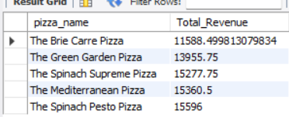
I. Top 5 Pizzas by Quantity
Select pizza_name, Sum(quantity) As Total_Quantity From pizza_sales
Group by pizza_name
Order by Total_Quantity Desc
Limit 5;
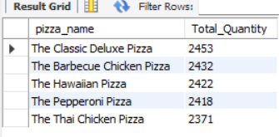
J. Bottom 5 Pizzas by Quantity
Select pizza_name, Sum(quantity) As Total_Quantity From pizza_sales
Group by pizza_name
Order by Total_Quantity Asc
Limit 5;
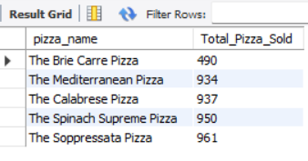
K. Top 5 Pizzas by Total Orders
Select Pizza_name,Count(distinct order_id)As Total_Orders From pizza_sales
Group by pizza_name
Order by Total_Orders Desc
Limit 5;
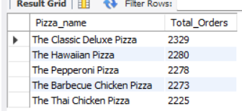
L. Bottom 5 Pizzas by Total Orders
Select Pizza_name,Count(distinct order_id)As Total_Orders From pizza_sales
Group by pizza_name
Order by Total_Orders Asc
Limit 5;


